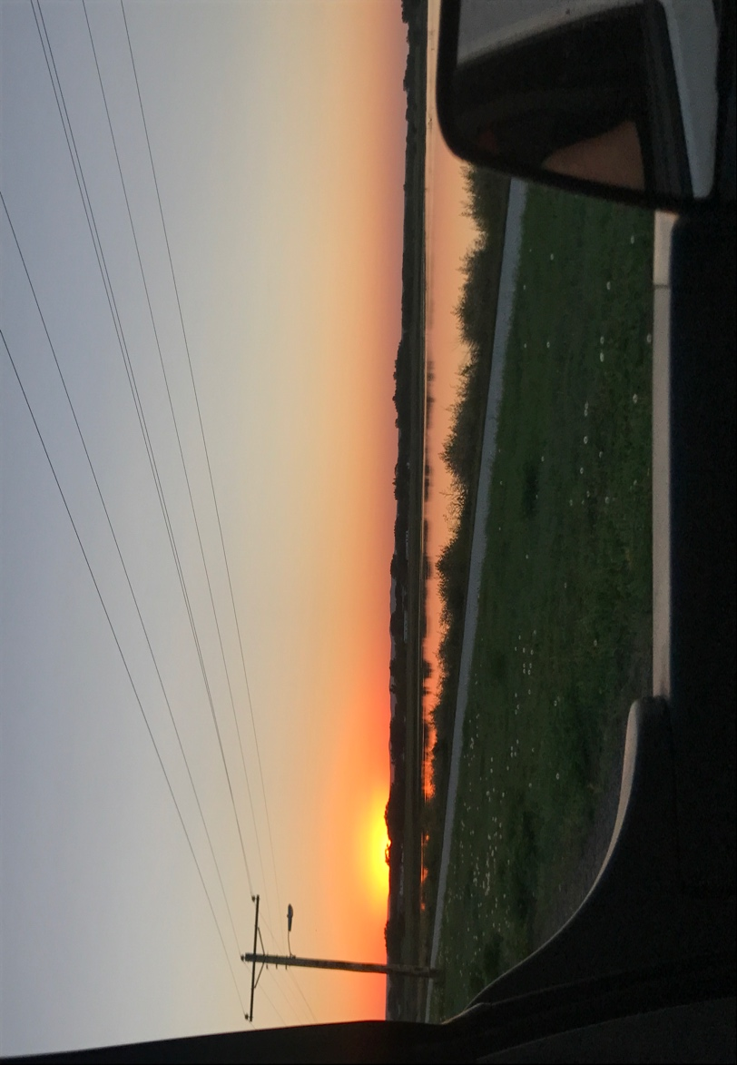 |  | SDEMSA  - District VII Newsletter  - January 2018
 |  | In This Issue
SDEMSA
District VII
Education

By the time everyone receives this newsletter we will be in the new year of 2018. I hope you all had a wonderful Christmas holiday! First I would like to say thank you all for allowing me to serve as your president for another 2 years! I am truly honored. Some of my goals for our district this term is to increase membership, get to know the men and women who serve our area, and get good quality hands-on training to your area! Now I am pleased to introduce our personal District VII Newsletter which will be sent out every quarter giving you the latest updates and news happening in our area and the association. I hope this will keep everybody in the loop of future trainings, conferences, and meetings. If you would like to put an article in this newsletter about trainings or news or having any suggestions please email me.
The training officers and I have been working hard the past few months getting a monthly education schedule completed and WE DID IT! There will be 70 hours of state approved education in our district in 2018!! We are hoping this will be successful and continued for years to come.

The district refresher planning is well underway and we should have a full schedule of events posted soon! Don’t forget to check out our website (www.sdemsadistrictvii.org) and subscribe to get updates as well. As always if you have any comments, questions, or suggestions please feel to contact me!
Thanks for everything you do and stay safe out there!!
Kate Roesler Paramedic

Letter from the President
by Kate Roesler
2018 Training Schedule
70 hours of free state approved training for all active SDEMSA members! See the schedule inside!
Page #2
24 Hour Refresher
To view column breaks, section breaks, and other formatting marks, on the Home tab, in the Paragraph group, click the pargraph mark icon.
Page #3

Monthly Education

This year we are implementing our own monthly education. There is a total of 70 hours of free state approved education available to all active SDEMSA Members.
For all non-members, the cost will be a one time fee of $30.00 to cover the association membership fee. Anybody can pre-register for any class at www.sdemsadistrictvii.org.
If you or someone you know would like to instruct one of these classes please contact Kate, McKenzie, or Brandon. We would like to utilize as many of our members as possible.

Introducing Our New Training Officer

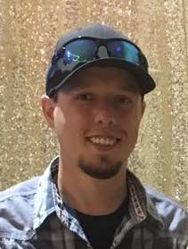

Hello! Name is Brandon Carlson, I have been in EMS for approximately two years. I started out as an EVOC driver for Mobridge Regional Hospital and have since progressed my education to the AEMT level. I am looking to get into Paramedic school this summer. I have helped with one EMT class and am currently helping teach another in Mobridge. I currently work full-time for Standing Rock Ambulance service as well as volunteer for Mobridge. I am very fortunate to be one of our districts training officers and am very thankful for this opportunity! This coming year we have trainings set-up in each town of our district and I plan on attending every

training possible. If there is any training that anyone would like to see, other than what we have scheduled, you are more than welcome to call or e-mail me or Mckenzie Hulm and we can work on getting it set-up.
I would like to be more of a hands-on training officer instead of sitting behind a computer and offering suggestions. I’m hoping everyone had a great holiday season and myself as well as the rest of our officers are looking forward to an amazing 2018!
-Brandon Carlson

Pre Refresher PEPP Course!
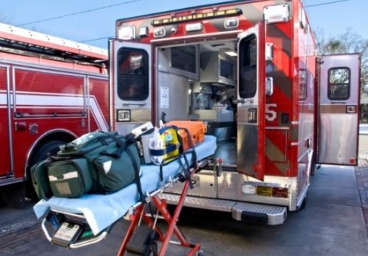

24 Hour Refresher

Hybrid PEPP Course
BLS PEPP Hybrid Course is being offered for this year’s Pre-Refresher which will take place Thursday, February 22nd from 5:30 pm-10:00 pm CST. Pre-registration is required to get the PEPP certification. Those interested will need to complete the online modules prior to the hands-on skills which will be completed on the 22nd in Mobridge. Cost will be $25.00 which will be reimbursed to you upon successful completion of the course (online modules, skills, and test). The BLS Hybrid Course provides 8.5 hours of CEUs.
If you don’t want the full course but would like to attend the hands-on training you are more than welcome to attend free of charge. 4.0 pediatric CEUs will be available.
For more information or to pre-register for the course please contact Kate at 605-848-2345 or katelynn.roesler@live.com. You can also pre-register at www.sdemsadistrictvii.org.

NEWs!

Beginning January 2nd the SD EMS Program will begin accepting EMT recertification applications for anybody whose certification is expiring in March 2018. You can send in your applications online at ems.sd.gov or by mailing in the appropriate paperwork to SD DOH, ORH/EMS, 600 East Capitol Ave, Pierre, SD 57501.
PLEASE REMEMBER if you are Nationally Registered you still must renew with the state by sending in your current NREMT and CPR cards.
EMS Day on the Hill
February 12, 2018 in Pierre SD.

For More Information
Contact Maynard Konechne at 605-730-0462 or mjkemtkc@hotmail.com

This year’s refresher is planned for February 23, 24, & 25 at the Mobridge Regional Hospital Education Room.
Friday classes will be from 1 pm to 8 pm. Registration will start at noon. Supper will be provided.
Saturday classes will be from 9am to 8 pm. Registration will start at 8 am. Lunch will be on your own. Supper will be provided.
Sunday classes will begin at 9 am with the District Meeting followed by classes until 4 pm. Lunch will be provided.

For More Information
If you have any questions please don’t hesitate to call, text, or email Kate, McKenzie, or Brandon.

We have a lot of speakers coming to Mobridge from across the state. SIM-SD will be here with the OB manikin to do simulations. All hours are state approved and will follow the State and NCCP guidelines.
The cost for the refresher this year will be $40.00 for active members and $70.00 for non-members which includes the association membership fee.
If you plan on only attending one day you will be given a discounted rate. Contact Kate for more

